Search & Quotation Modules

Search Page(FCL):
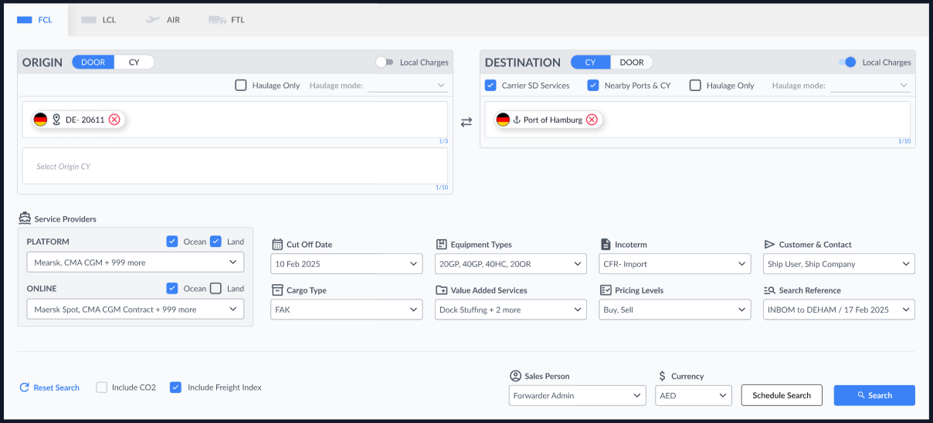

1. Service Mode Selection (Door/CY)
- When Door is selected, only the following options should be available: Haulage Only, Haulage Mode, and Local Charges.
  - Independent L1 and L5: When a user wants to search and quote an L1 or L5 rate separately the user would need to enter the Origin Door, POL, POD and also check the Haulage only button.
  - Local charges: The L2, L4, L2Cha and L4Cha are the local charges. When the check box is checked we will stitch these legs to the Ratecard, else we just do not show these charges. Origin-L2,L2Cha; Destination-L4,L4Cha;
- When CY (Container Yard) is selected, all options should be available for selection (except Haulage only).

2. Carrier Selection
- Users can select service providers similar to how they select carriers.
- Service providers are categorized into:
  - Platform Carriers: We will show the cleaned up carrier list along with the Vendor specific Carriers.
  - Online Carriers: We show the entire Online carrier list, but will disable the selection for the carriers that are not integrated.
- The carrier selection is only for FCL

3. Filters & Search Attributes
- The following fields should be available and function identically to the previous version:
  - Cut-off Date
  - Equipment Type (MAX 4 loadtypes)
  - CO₂
  - Freight Index
  - Sales Person
  - Currency
  - Search Reference

4. Reset Functionality
- Upon clicking “Reset”, the following fields are cleared or reset:
  - Cleared: Origin, Destination, Incoterms, Search Reference, CO₂, Freight Index, Customer & Contacts
  - Reset to defaults:
    - Sales Person → Current logged-in user
    - Cargo Type → FAK
    - Equipment Type → 20x1
    - Carrier selection → My Profile
    - Currency → Profile Currency

5. Value Added Services (VAS)
- The platform should allow users to select from:
  - Stuffing
  - Import Customs Brokerage
  - Export Customs Brokerage
- These VAS will have an impact on the search results.

6. Pricing Levels
- System should support two pricing levels:
  - Buy
  - Sell
- When one is selected only that gets displayed for the user.

7. Incoterms Behavior
- The system must dynamically update Incoterms listed based on the legs selected from locals and cy selections.
- Leg logic should follow domain configuration rules.

8. Customer & Contact Info
- Customer and Contact information includes:
  - Customer Name, Company Name and other information.
- This works the same way as in the old UI.

9. Domain Configuration Options
- Admin or domain settings should allow configuration of the following fields:
  - Incoterms
  - Carrier Selection
  - Pricing Levels
  - CO₂ check box
  - Freight Index

10. Schedule Search
- The search option allows users to search schedules, it is all the same as the old UI.

Rate Card:
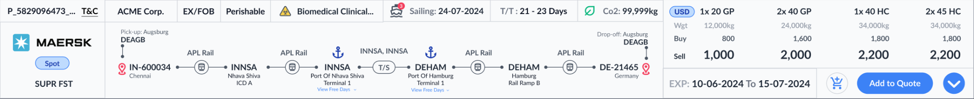

Rate Card Design

Card Layout
- The major additions to the rate card
  - Detailed mini schedules with services
  - Rates segregated based on loadtype(Buy,Sell and weight)
  - Basket icon
  - View details
  - Custom Field - this can be added when the rate sheet is uploaded and will be visible on the rate card
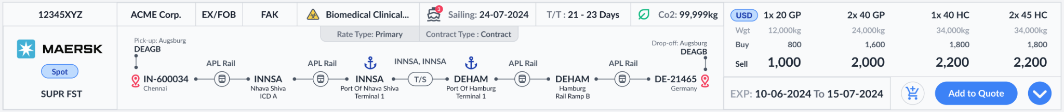
- Other details we have just changed the design rest same as the old UI
  - Display the customer name (ACME Corp.).
  - Cargo type (FAK, Hazordos)
  - Commodity(Perishable, Biomedical Clinical…)
  - Sailing date (24-07-2024)
  - Transit time (T/T) range (21–23 Days)
  - CO₂ emission value (99,999 kg)
  - Terms and conditions
  - Contract number or Rate ID

Route Visualization
- Display the full route in a visual format with icons and labels for:
  - Pick-up location (Augsburg – DEAGB)
  - Origin Door (IN-600034 Chennai)
  - Freight (INNSA to DEHAM)
  - Destination door (DE-21465 Germany)
  - Drop-off location ( Augsburg - Germany)
- Representing service modes (rail, sea) with appropriate icons (train, ship).
- Show transshipment (T/S) points clearly labeled.
- Provide a clickable "View Free Days" like we have now in the old UI.

Actions & Validity
- Show validity period of the rate (EXP: 10-06-2024 to 15-07-2024).
- Provide an “Add to Quote” button to add the rate to a quote builder.
- Provide an “Basket” button A CART icon, is used to add a ratecard to the basket.
- Include an action dropdown (down icon) for additional actions (same as view details).

Optional Enhancements (UI/UX Considerations)
- Tooltip or hover-over popups for:
  - Incoterms
  - CO₂ value
  - Terminal names and codes
- Alert indicators (⚠️) for Showing warnings when a rate card is incomplete.

Search Results Page:
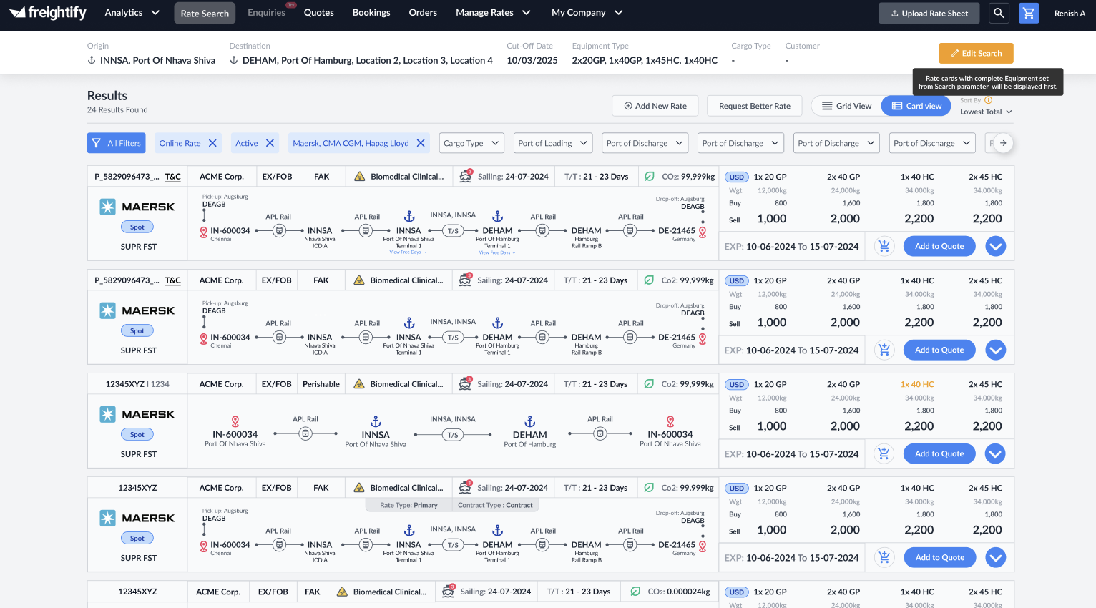
This page displays the list of rate cards available based on the entered search criteria. It includes tooltips to provide disclaimers and additional context, along with various filters to streamline the results. Users can also initiate a new search directly from this page.

Add to Quote:
This button would allow the user to select multiple cards after which the user can start the quote creation process or just move to the basket.

Add New Rates:
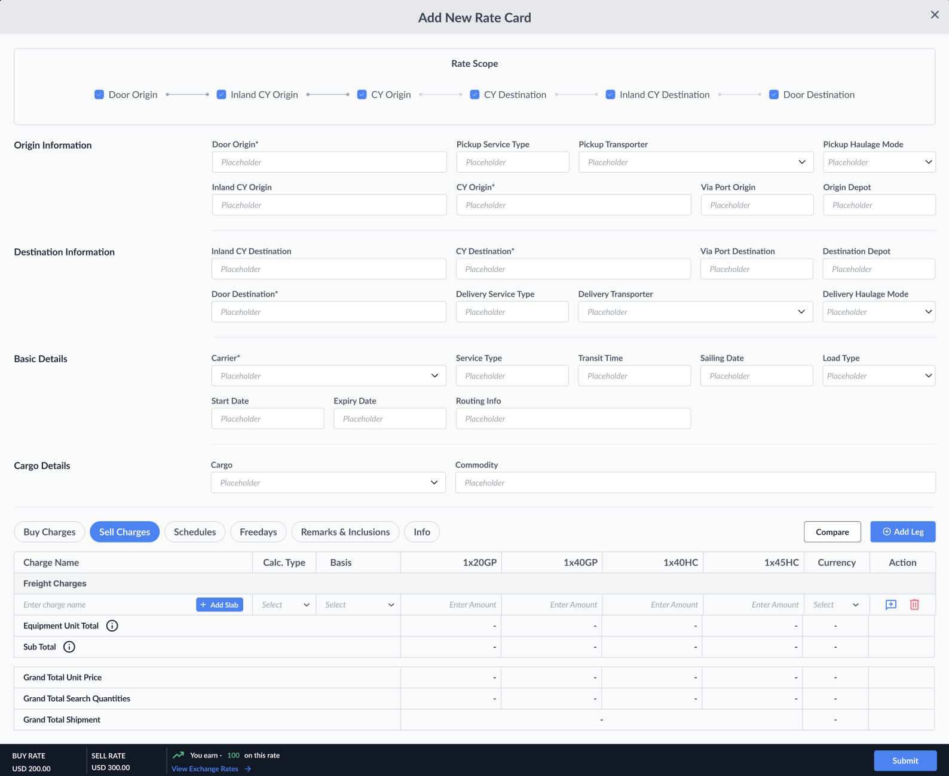
- The user must first define the scope of the rate being created. Based on the selected scope, relevant Origin and Destination fields will be displayed.
- All required fields will be marked with a mandatory indicator.
- Once the details are filled in, the rate will be added to the corresponding search result. Additionally, it can be saved to the Basket for later use.

Export Rates:
The Excel Export option serves as an alternative to the Enterprise Layout (Grid View). When a user clicks this button, it downloads all the rates returned in that specific search result.
There are two export options available:
- Buy and Sell – includes both sets of rates (available to primary users).
- Sell Only – includes only sell rates (available to secondary users by default).
- Buy or sell Only – includes only buy or sell rates (available to primary users).

View Details(FCL):
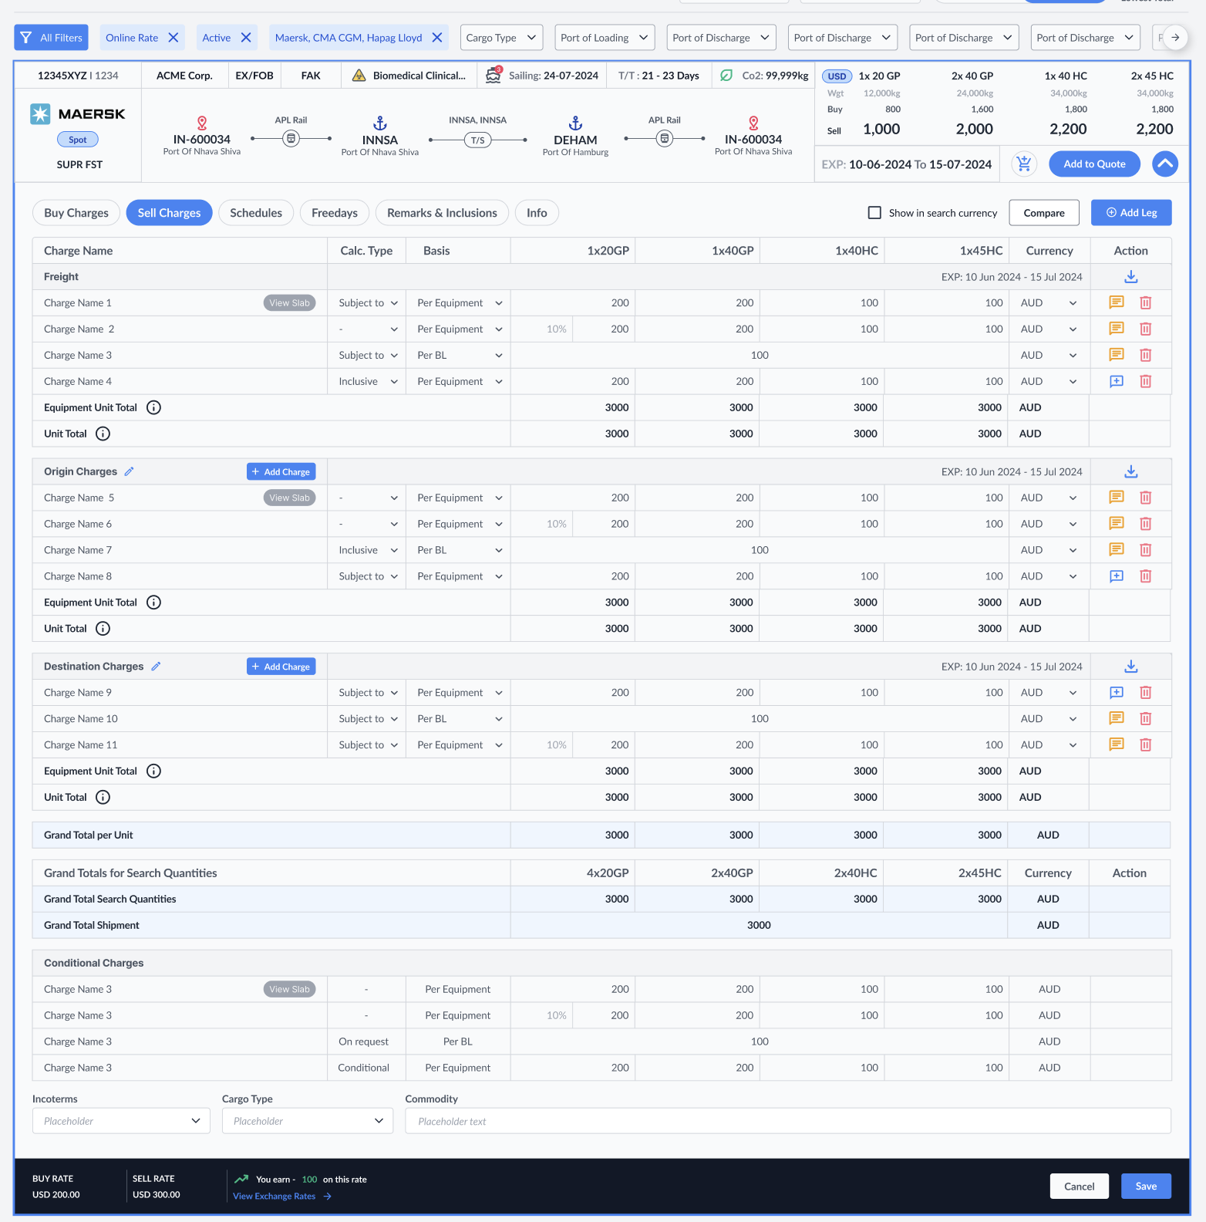

Buy and sell:
Buy and sell are in two different tabs, when a user wants to compare he can use the compare button on the top right of the charges.

View Slab:
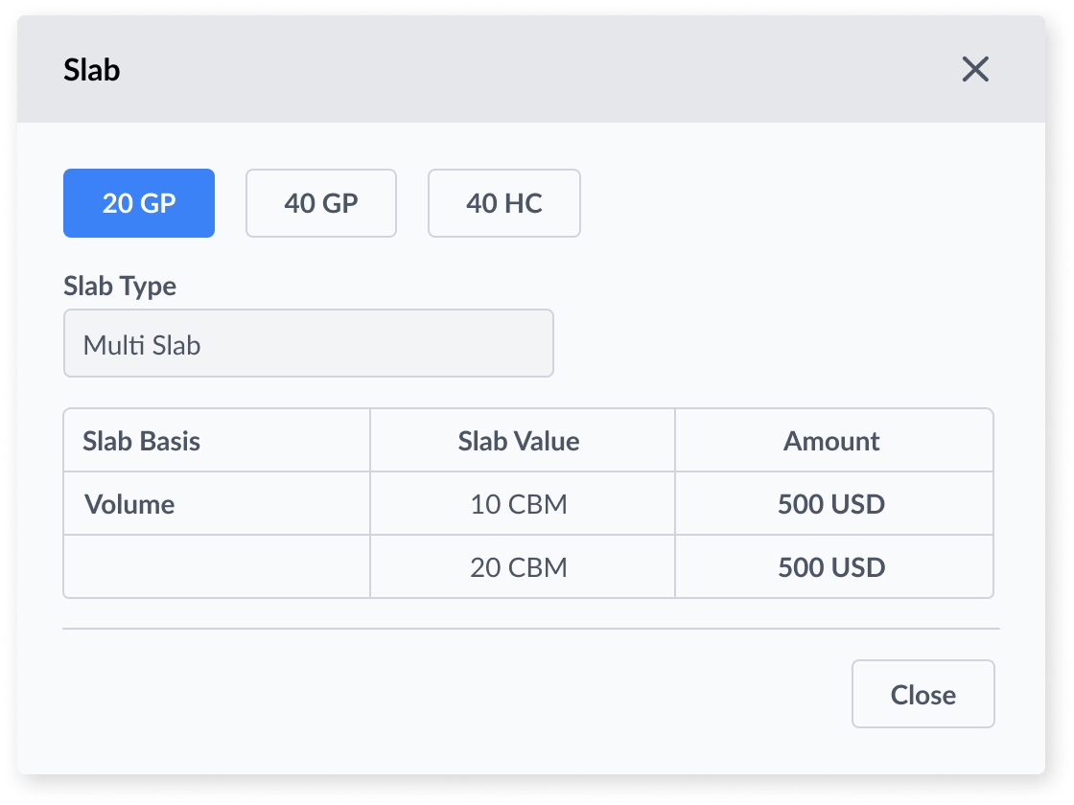
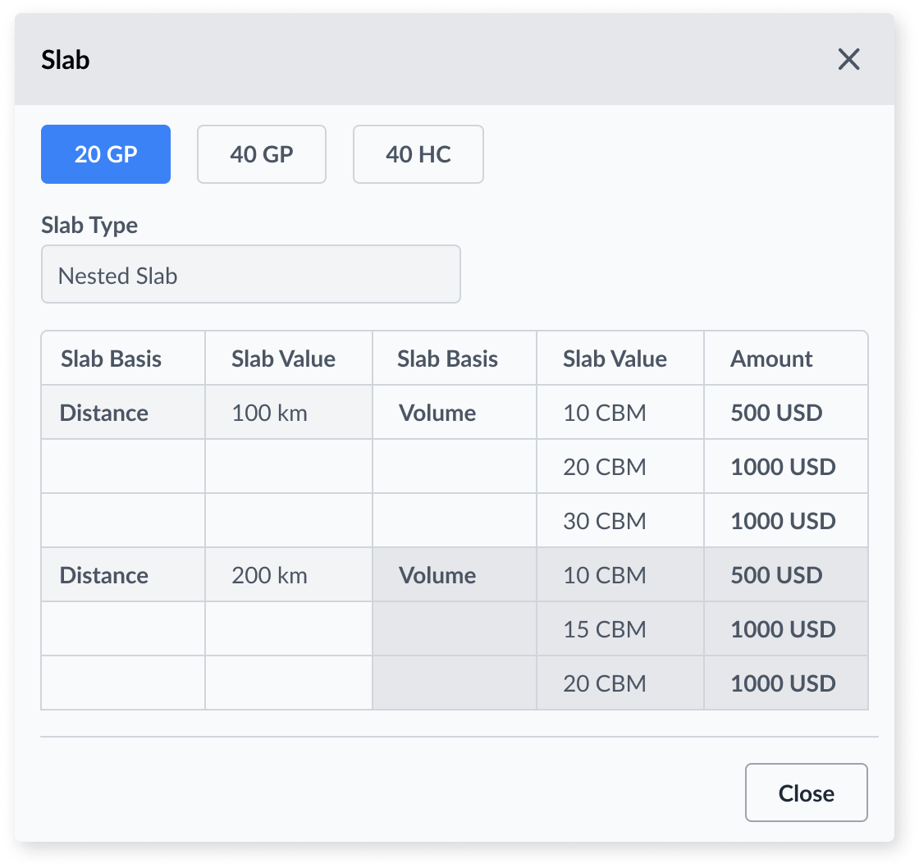

Totals:
- Equipment Unit Total: The sum of all equipment-based charges, calculated for a single unit within that leg.
- Unit Total: The total cost for a leg, including one unit of all non-equipment charges plus the Equipment Unit Total.
- Grand Total per Unit: The combined total of all Unit Totals across all legs.
- Grand Total for Search Quantities: The Grand Total per Unit multiplied by the search quantity entered by the user.
- Grand Total Shipments: The total cost of all equipment-related charges across all legs, based on the full search quantity.

Download Source:
The Download source button is used to download the respective ratesheet.

Compare:
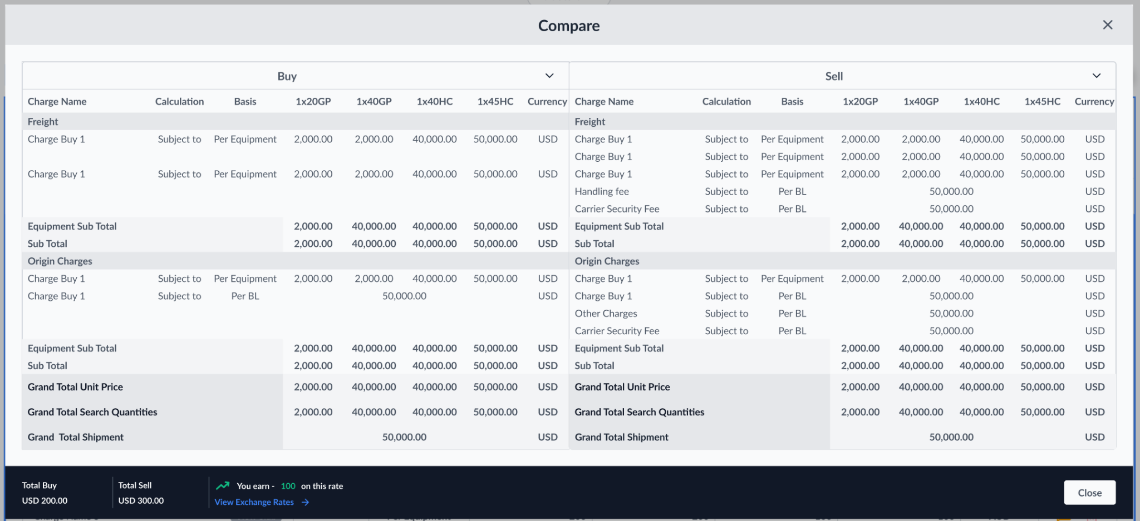
We will open a popup to show buy and sell side by side for the user to compare

Info:

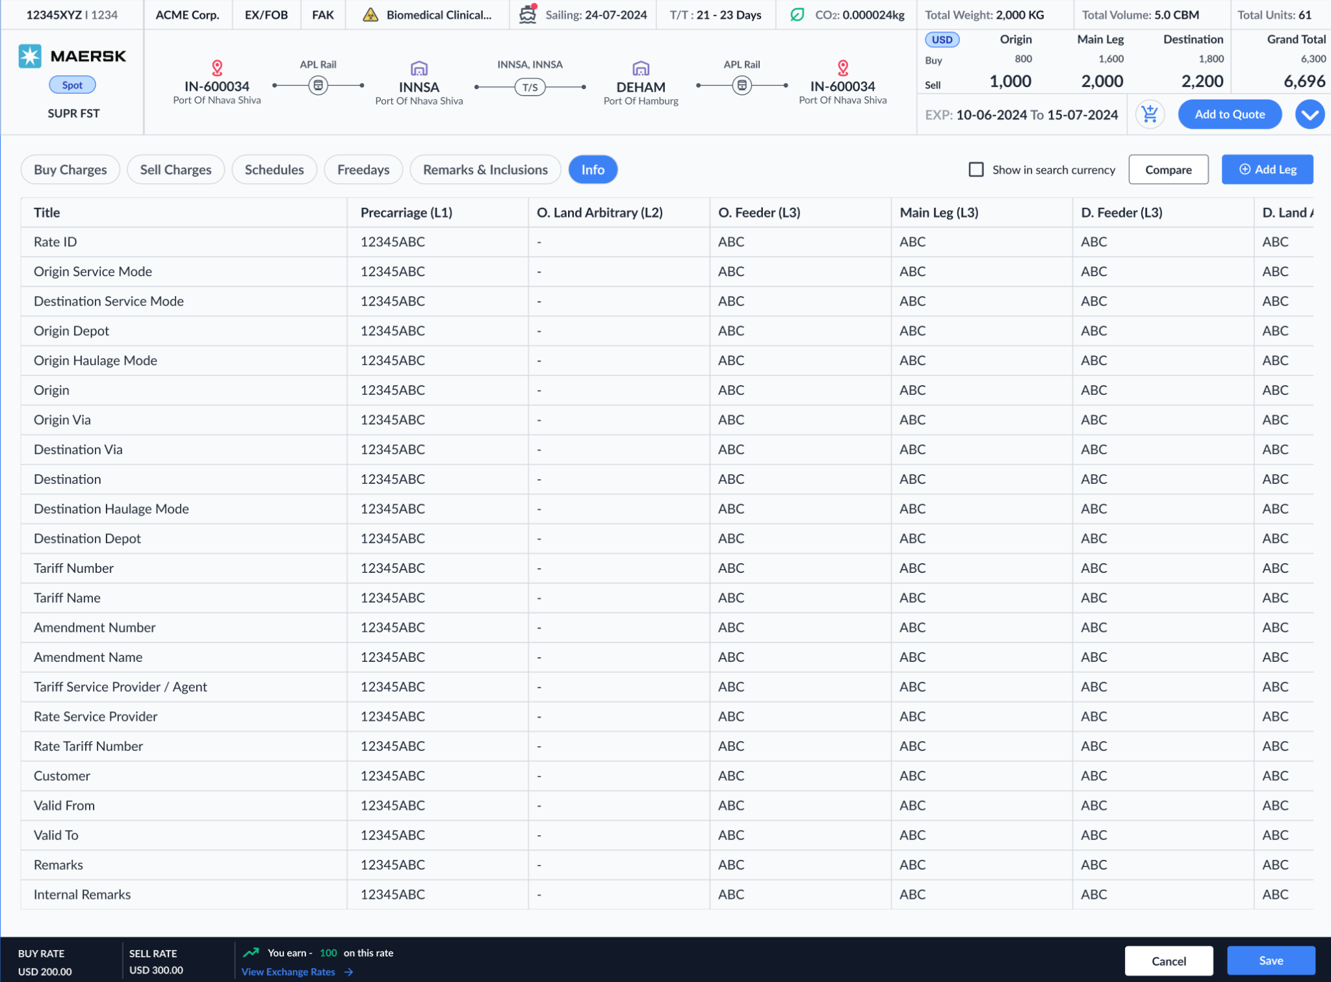
The Info tab consists of the entire details of the rates fetched based on the legs.

Quotation:
The new quote editor is divided into three key sections for a seamless workflow:
- Header & Customer
- Pricing & Footer
- Output Configuration

Step 1- Headers and Customer:
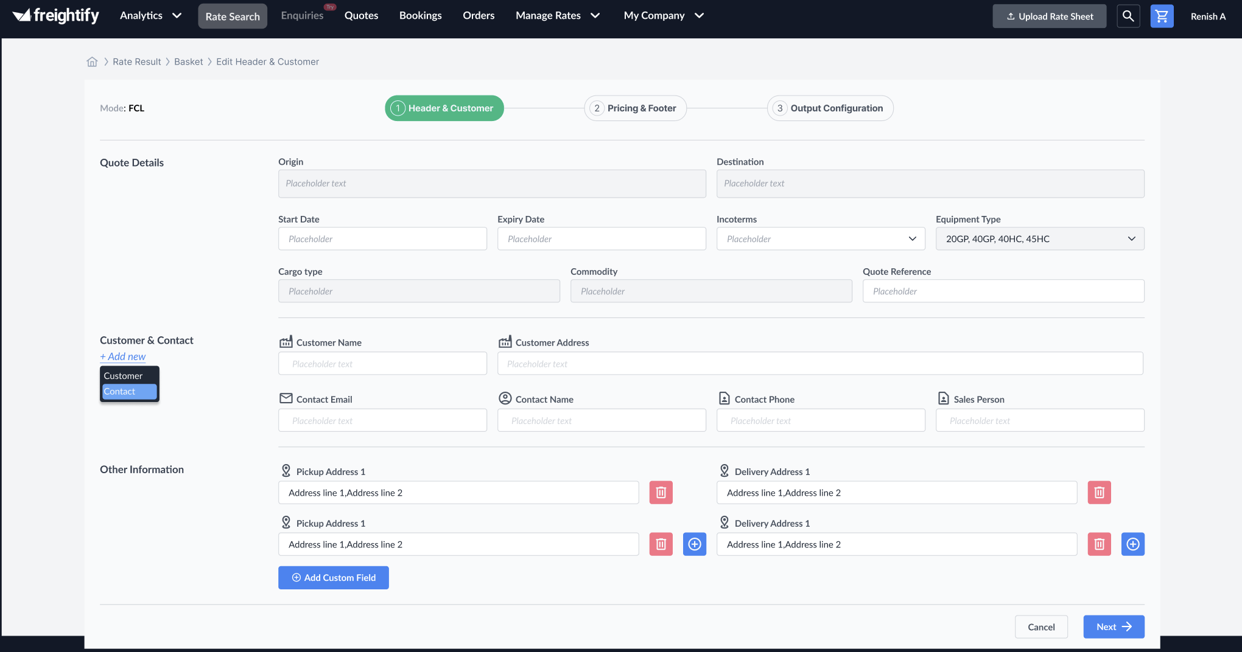
This section captures essential details related to the shipment, customer, and contact information.
Note: Most of the above details will be populated from the data in search and card.

Quote Details
Most of the details(Origin, Destination, equipment type, cargo type, commodities) here will be fetched from the rate cards selected.
- Origin / Destination: The port or location details
- Start Date / Expiry Date: Define the validity period for the quote.
- Incoterms: Select applicable trade terms from the dropdown(Will be limited based on the Legs in rate card)
- Equipment Type: Choose equipment type(can add new loadtype that is not in rate card but removing a loadtype will impact the rate card)
- Cargo Type: Specify the type of cargo
- Commodity: The commodity name
- Quote Reference: Optional field for internal or external reference codes.

Customer & Contact
We’ll list the existing customers name&email and Company name will be populated as we type in the details.
- Use the + Add new dropdown to create new customer or add a contact for an existing customer.
- Customer Name (mandatory)
- Customer External Reference Code (optional)
- Customer Address (optional)
- Contact Email (mandatory for a customer contact, not for a customer company)
- Contact Name (mandatory for a customer contact, not for a customer company)
- Contact Phone (optional)
- Sales Person: Assign the responsible salesperson for this quote.

Other Information

Pickup & Delivery Addresses
- Addresses can be added for both pickup and delivery(will be printed in the PDF)
- Click the ➕ button to add more address fields.
- Use the delete icon to remove unnecessary fields.

Custom Fields
- Click Add Custom Field to include additional custom data relevant to the quote(Will be printed on PDF above the charges table)

Navigation Controls
- Next: Proceeds to the Pricing & Footer step.
- Cancel: Discards current changes and returns to the previous screen.

Step 2 Pricing and Footers:
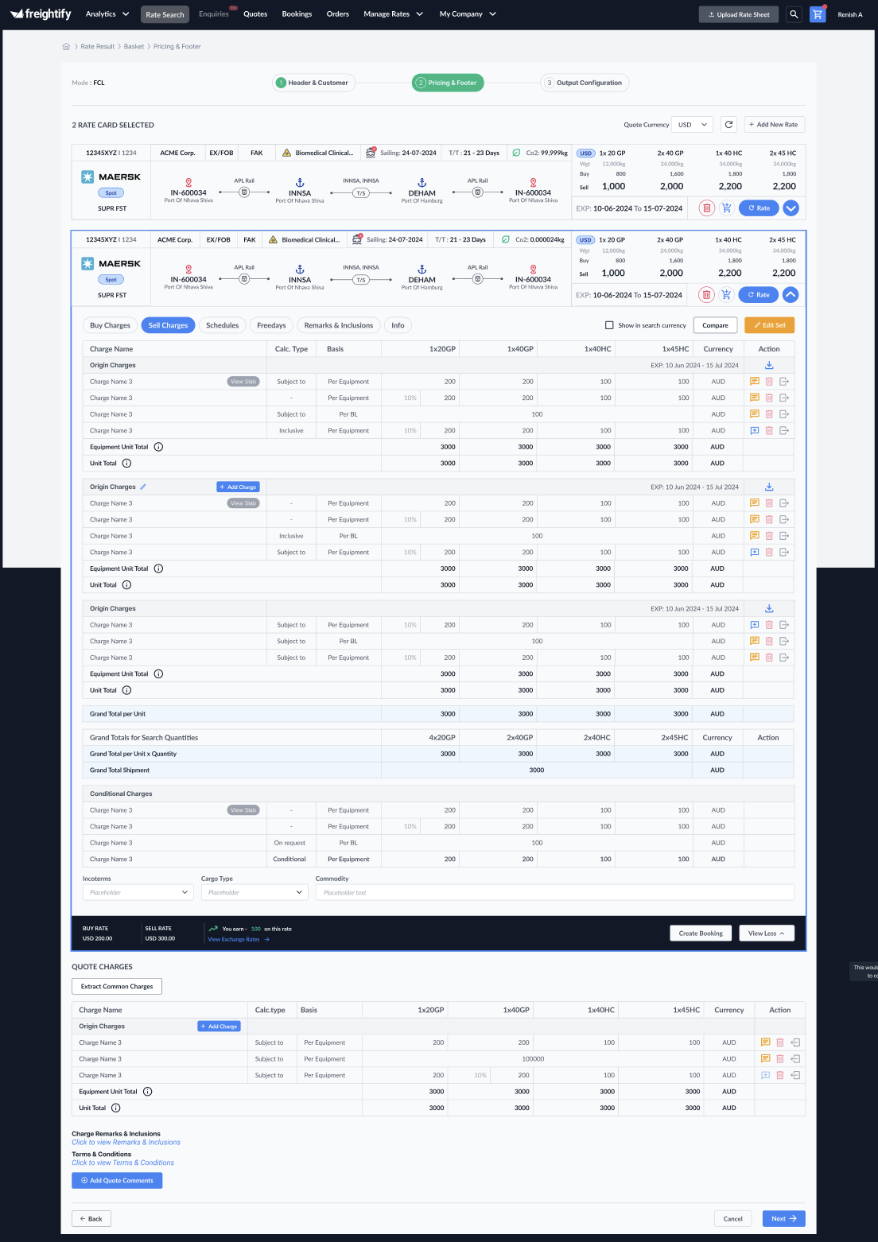
This section manages how pricing information is configured and how the final quotation document is presented.
Quote Currency: Allows you to change the currency of the quote. All charges will reflect the updated currency accordingly.
Add New Rate: Functions the same as in the Rate Results section. The created rate is added directly to the quote.
Delete Rate Card: Removes the selected rate card from the quote.
Rate Refresh: Performs a new rate search using the specified port pairs (which can also be edited) and adds new rate cards to the quote.
Expand (View Details): Expands the rate card to show detailed information.
Compare: Displays Buy and Sell rates side by side, allowing easy comparison.
Edit Sell: Allows you to modify the Sell rate after expanding the rate card.
Add Charges: Adds a new charge line within a leg.
Add Charge Comments: Enables users to add both internal (not shown in the PDF) and external (visible in the PDF) comments to a charge.
Delete Charges: Removes a selected charge line from the leg.
Move to Common Charge: Moves specific charges to the Common Charges section.
Download Source File: Downloads the original source rate sheet associated with the selected leg.
Common Charges: Displays charges that are shared across all rate cards within the quote.
Add Quote Comments: Combines remarks from all rate cards. Users can edit these comments as needed.
Incoterms, Cargo Type, and Commodity: These details are auto-filled based on the selections made in the previous screen.

Copy Quote:
Clicking on copy quote will take you to the Header and Customer section the first step in Quote Creation, All the details will be populated and those can be edited as desired to create a new Quote.
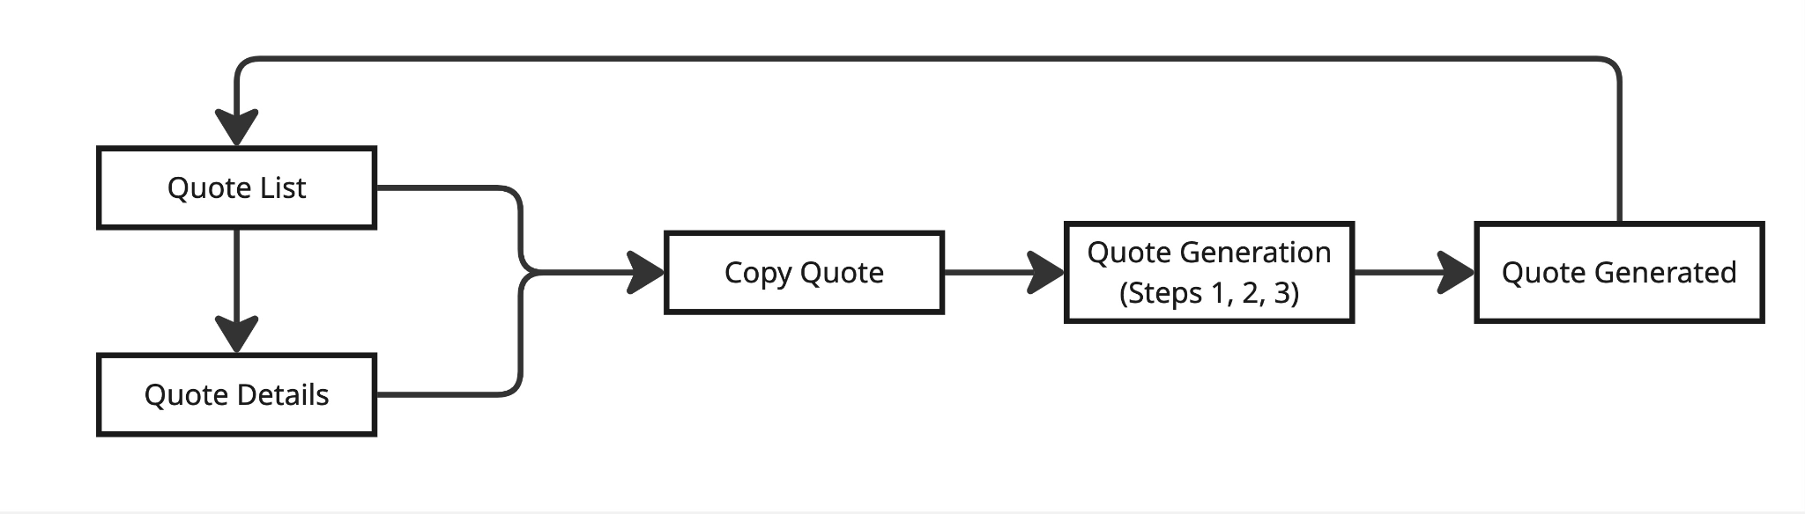

Rate Refresh:
Performs a new rate search using the specified port pairs (which can also be edited) and adds new rate cards to the quote.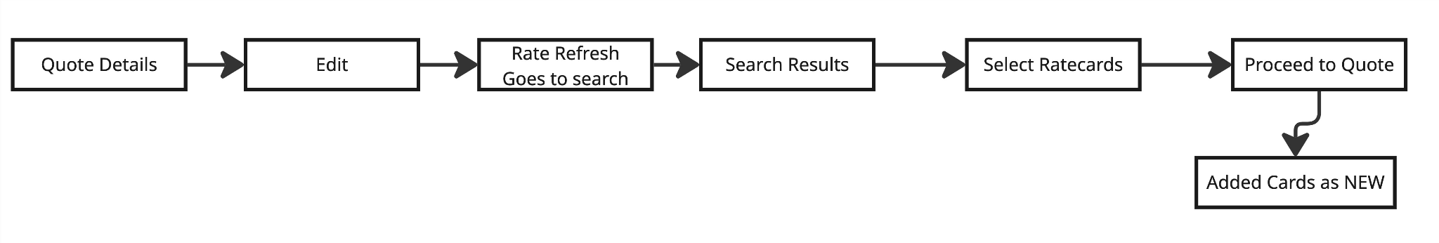

Pricing Display
Control what pricing details are visible on the quote.
- Show Buy: Displays cost price (buy rate).
- Show Sell: Displays customer-facing rate (sell rate).

Navigation Controls
- Back: Returns to the Header & Customer step.
- Next: Proceeds to the Output Configuration step.
- Cancel: Discards current changes and exits the quote editor.

Step 3 Output Configuration:
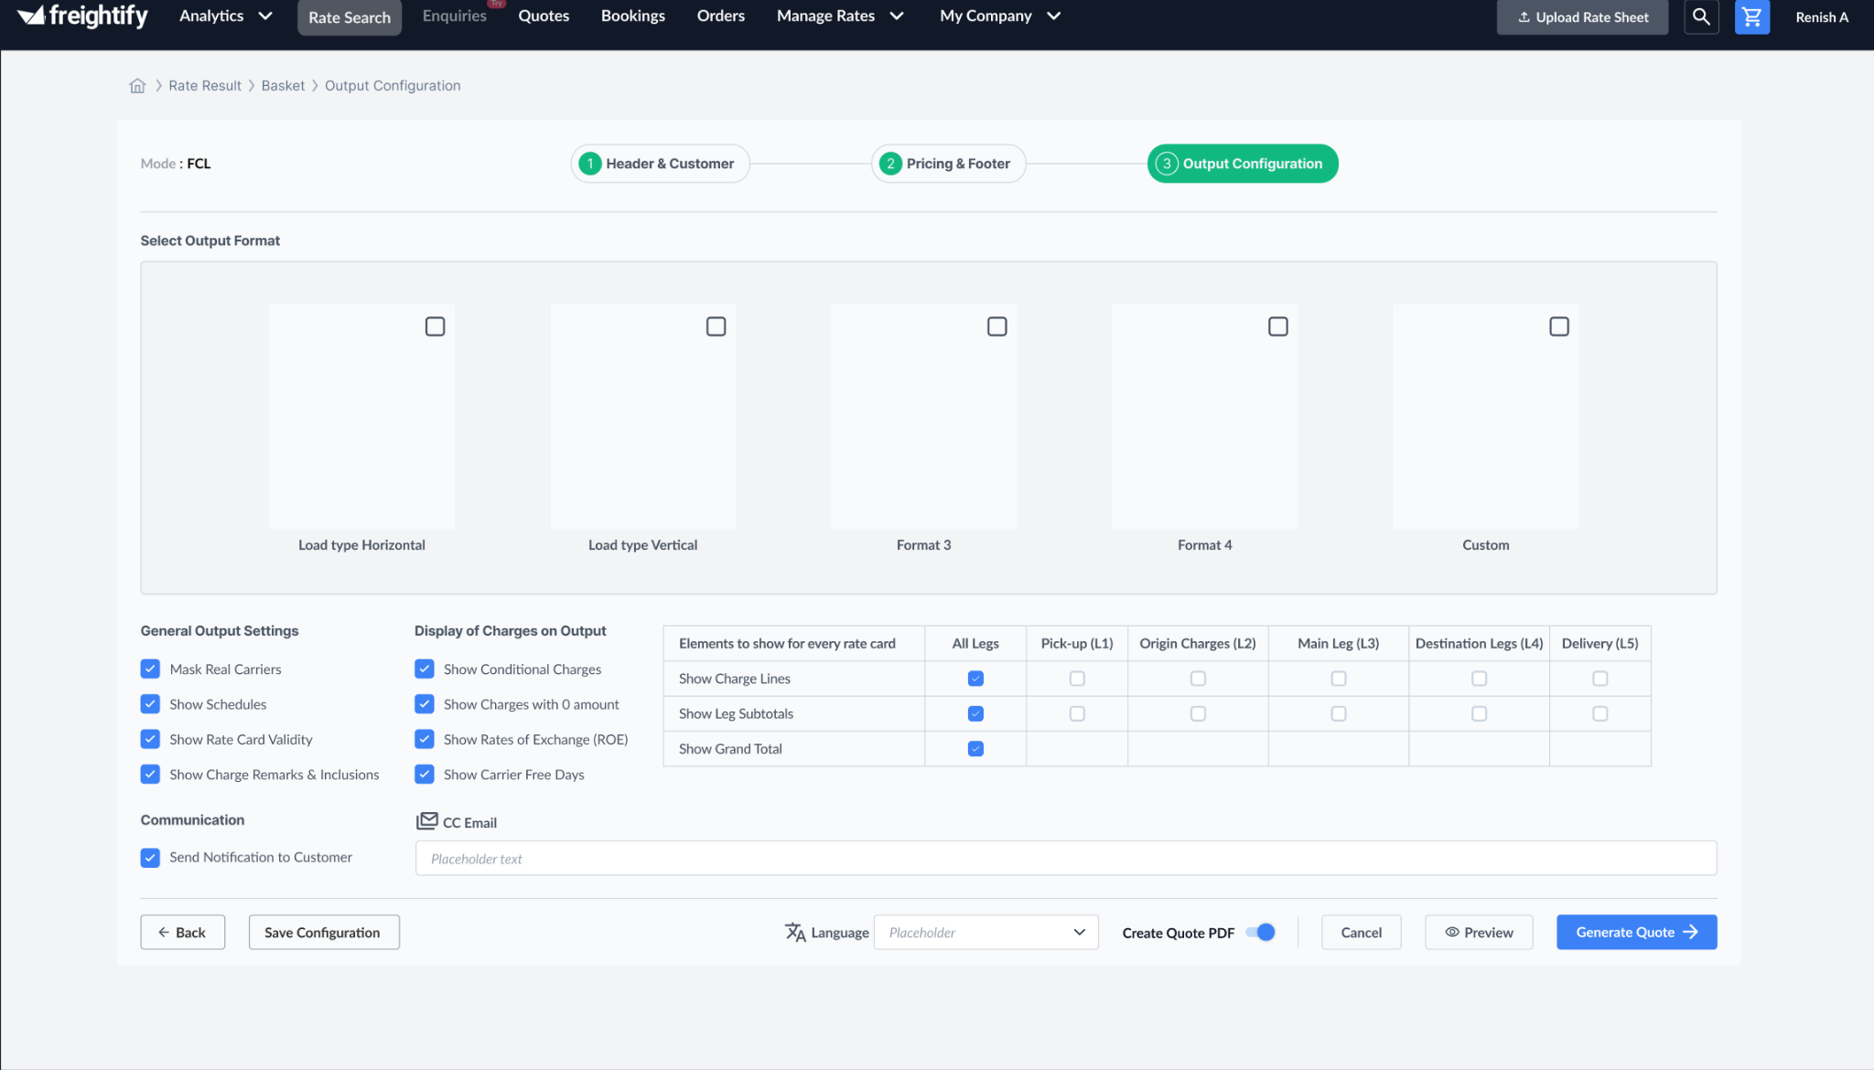
This section defines the visual format and content preferences for the generated quote PDF. This can be divided into 4 sections
- Format Selection
- Display configuration
- Communication
- Quote preference

Format Selection
The user can select the desired format for the quote PDF. Only one format can be selected at a time.

Display configuration
General Output Settings
Enable or disable the following options as needed:
- Mask Real Carriers: Hides actual carrier names.
- Show Schedules: Includes sailing schedule information.
- Show Rate Card Validity: Displays Rate card validity dates on quote PDF.
- Show Charge Remarks & Inclusions: Quotes Remarks and Inclusions are displayed in the PDF.
Display of Charges on Output
Toggle visibility for:
- Conditional Charges
- Charges with Zero Amount
- Rates of Exchange (ROE)
- Carrier Free Days
Charge Breakdown visibility by Leg
Decide what to show for each leg of the journey (All Legs, Pick-up, Origin Charges, Main Leg, Destination, Delivery):
- Show Charge Lines
- Show Leg Subtotals
- Show Grand Total
Selections apply per leg using checkboxes.

Communication
- Send Notification to Customer: Toggle to automatically notify customer once the quote is generated.
- CC Email: Option to include additional recipients via email.

Quote preference
Language: Select the language for the quote output document from the dropdown list.(ENG, SPN, POR)
Create Quote PDF: Toggle ON to generate a PDF of the quote.
Preview: View a preview of the quote PDF.
Generate Quote: Finalize and create the quote.
Cancel: Exit the quote creation process.

Basket:
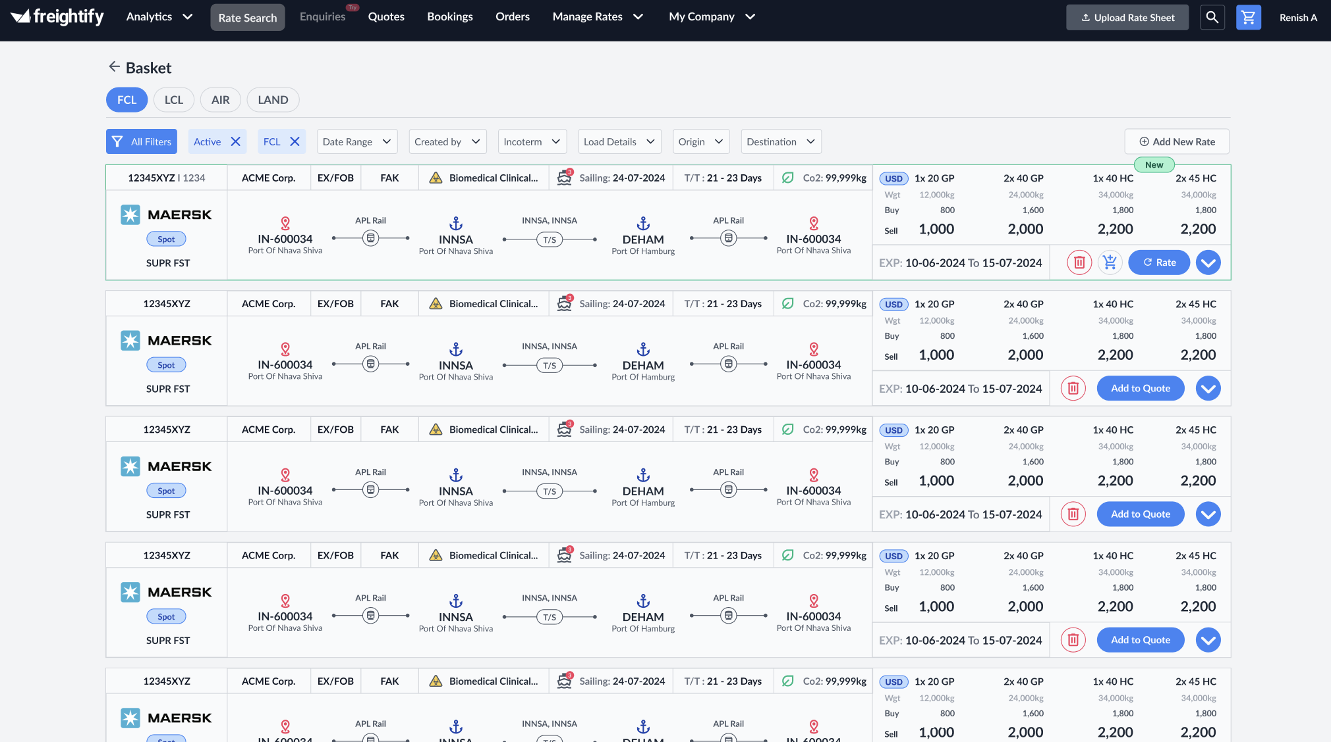
The Basket is an enhanced version of the Cart, designed to temporarily hold rate cards for a defined period. Rate cards added to the Basket will retain all the properties they had at the time of search.
Rate cards can be moved into the Basket from Search Results, Quote Details, or during a Rate Refresh.
While the rate cards in the Basket cannot be directly modified, they can be used to create or edit a quote. However, any changes made during this process cannot be saved back to the Basket.
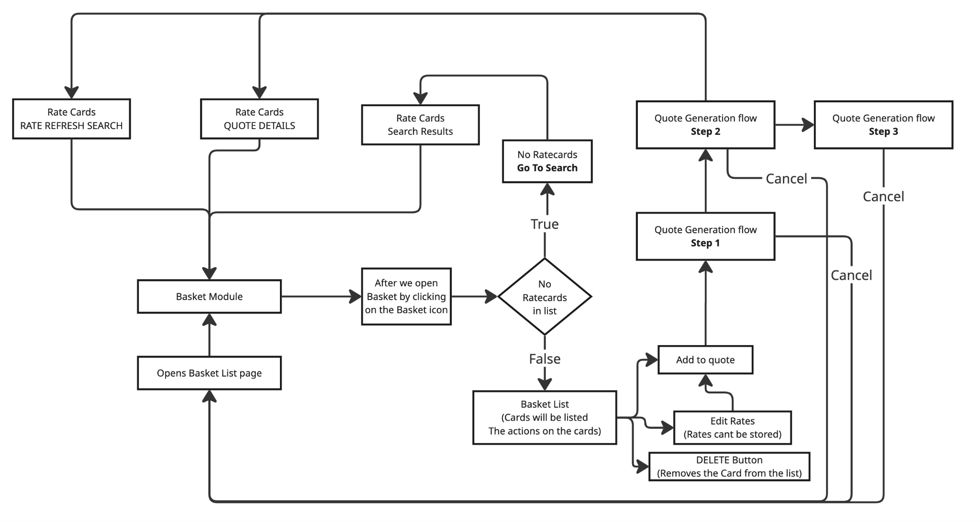

Primary User:
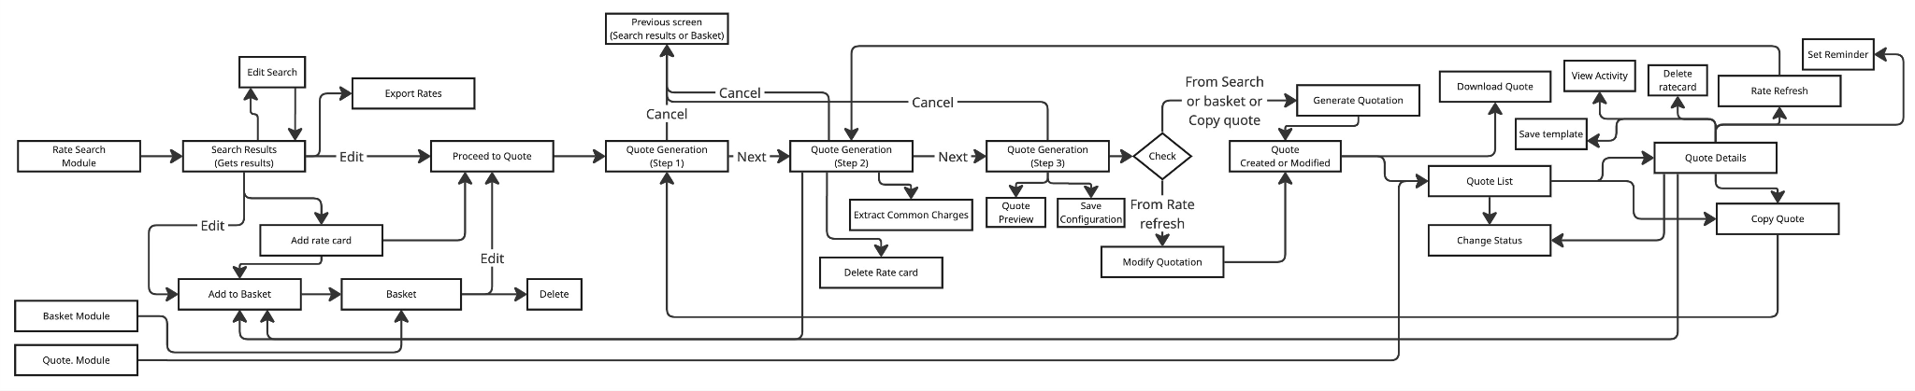

Secondary user:
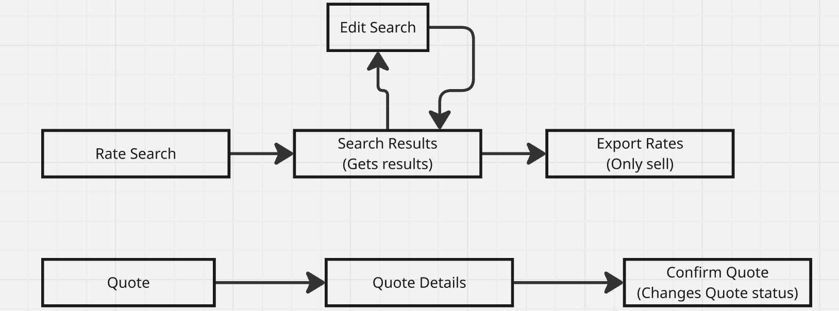

Search Page:
- The carrier selection option must be removed.
- Must also remove customer and contact along with sales person and pricing levels
Search Results:
- The “Add to Quote” button must not be available.
- No “Buy Rates” option should be displayed on the rate cards.
- The “Add New Rates” button at the top should be removed.
- No download source file
- Change buy charges and sell charges to just "Charges"
Search Results - View Details:
- No “Buy Rates” option should be available in the detailed view.
- Editing of any details should be restricted.
- No info tab
- Hide internal comments
- No Compare
Quote Page:
- Users can only view existing quotes.
- The only available action should be downloading the PDF.
Others:
- No basket
- No move to TMS

CRUD:

SEA-FCL (Full Container Load)
Create:
- Search for rates
- Add a new rate card
Read:
- Search and view rate card details
Update:
- Search and view details
- Edit rates
- Add selected rate to a quote
Delete:
- [Functionality not available]

SEA-LCL (Less than Container Load)
Create:
- Search for rates
- Add a new rate card
Read:
- Search and view rate card details
Update:
- Search and view detail
- Edit rates
- Add selected rate to a quote
Delete:
- [Functionality not available or not specified]

Quote Module
Create:
- Add to Quote (from search results or basket)
- Copy existing quote
- Save as template
- Log activity in activity monitor
Read:
- Access Quote module
- View quotes in listing page
- View quote details
- Set reminders
Update:
- Edit quote and save changes
- Refresh rates
- Save updated version as template
- Update Status in quote listing
Delete:
- [Functionality not available or not specified]
Basket
Create:
- Add to basket from:
  - Search results
  - Quote details
  - Quotation step 2
Read:
- View basket from top-right icon
- See basket listing
- (Go to basket in results) - have to confirm
Update:
- Edit item before proceeding to quote
(Note: Edits are not saved in basket; they carry over to the quote only)
Delete:
- Remove cards from the basket

